* **Platform shooting;**
* **1 vs 1 type combat;**
* **Local multiplayer;**
* **Controller support;**
* **Pixelated art;**
* **Jump around;**
* **Move around;**
* **Grab power-ups;**
* **Dodge your enemy;**
* **Use knifes;**
* **Fire bazookas;**
* **Pump shotguns;**
* **Shoot pistols;**
* **Punch everything;**

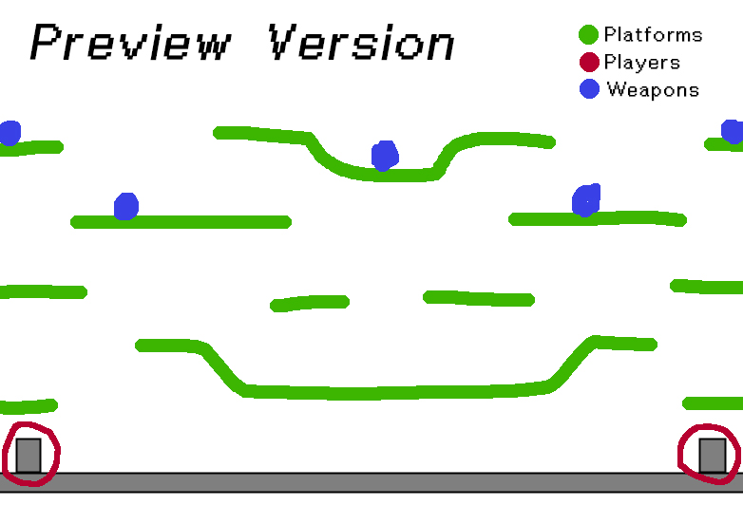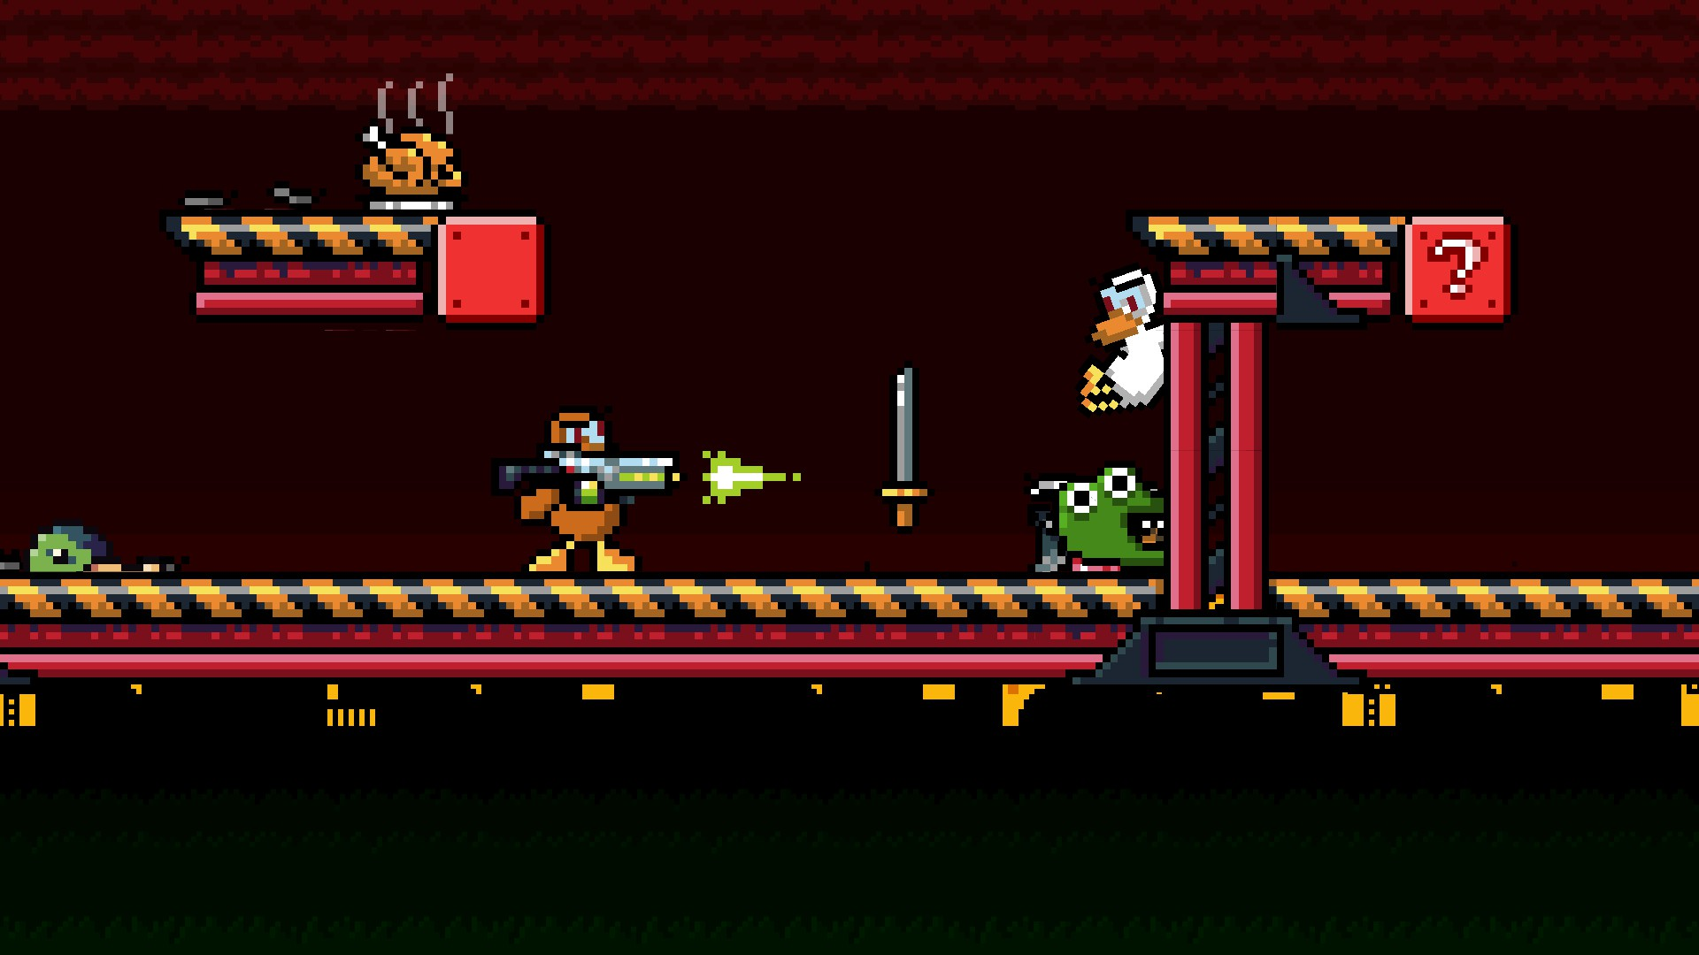

**Do all of the above and more on this brand new fast-paced, action-packed platform shooting game by Ana Rita Lamelas and João Fonseca.**

**Don’t blink.**

